Kindergarten Student Schedule
Instructional Delivery Model | Time | Activity
(LIVE) | SEL (Check-In)  7:45 - 8:00 | SEL (Check-In)  (15 min,/Synchronous- LIVE)
(LIVE) | Reading  8:00 - 8:20 | Reading  Teach Foundational Reading Skills/Green Band  (20 min./Synchronous -Live)
 | Reading  8:20-8:40 | Reading Independent Activities  Asynchronous/Unplugged -(20 minute)
Break
8:40-8:50
(LIVE) | Language Arts  8:50 - 9:20 | Language Arts/Writing/Social Studies Integrated  (and/or) Small Group Instruction  (30 min./Synchronous-Live)
Break
9:20- 9:30
 | Reading  9:30- 9:55 | Reading Integration Activities  (25 min./Asynchronous-Independent Work)
(LIVE) | Science/Social Studies  9:55- 10:15 | Non-Integrated Subject  Science- 20 minutes-LIVE
(LIVE) | Exploratory  10:15 – 10:50 | Exploratory  35 min- LIVE
(LIVE) | Science/Social Studies  10:50 – 11:00 | Conclusion of Non-Integrated Subject  Science- 10 minutes-LIVE
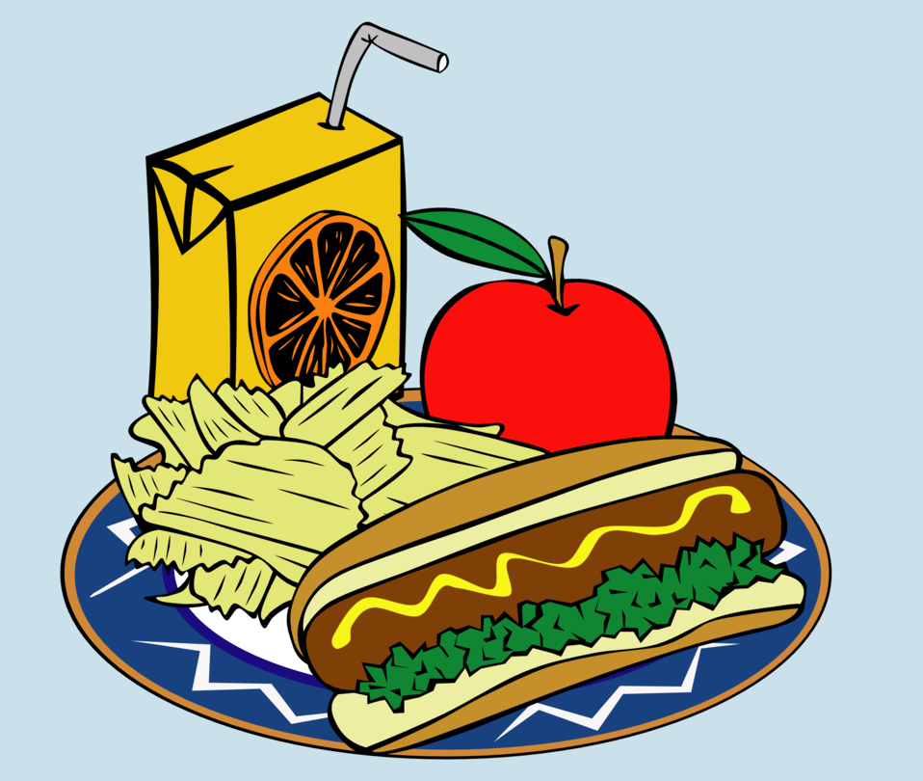 | Lunch 11:00 - 11:40 | LUNCH -40 min.
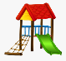 | Recess  11:40- 11:55 | Recess  15min
(LIVE) | Math  11:55- 12:25 | Math (30 min./Synchronous- LIVE)
 | Math Small Group  12:25-12:50 | Math Small Group  (25 min. Asynchronous- Small Group)
 | BREAK  12:50- 1:00 | Break  10 min
 | Math  1:00-1:30 | Math  (30 min Asynchronous- Independent Work)

